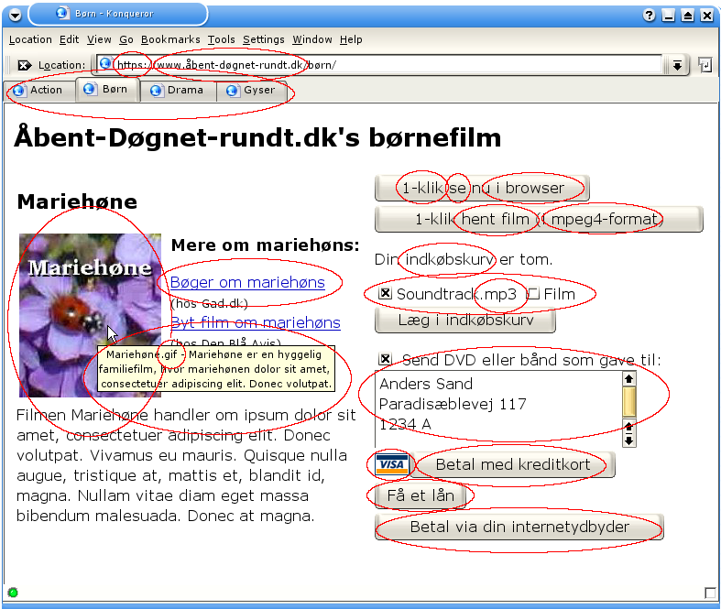
- åbent-døgnet-rundt.dk - ÆØÅ i domænenavne: EP1159820
- [Drama] [Børn] [Action] [Gyser] - Faneblade: EP689133
- Mariehøne er en hyggelig... - Pop-up vindue: EP0537100
- Se - Videovisning via web: EP0933892
- Hent film - Videovisning via web (samme som ovenfor): EP0933892
- mpeg4-format - Udbredt videoformat til download af video: Mere end 40 patenter (herunder DK638218)
- Indkøbskurv - Konceptet indkøbskurv: EP0784279
- Soundtrack.mp3 og Film - E-handel med serviceydelser: DK/EP738446
- Soundtrack.mp3 - MP3 er et udbredt lydformat: DK287578
- Betal med kreditkort - Kreditkortbetaling via internettet: EP820620
- Send som gave - Beregning af korrekt gaveadresse ud fra mangelfulde oplysninger: EP927945
- Få et lån - Automatisk lån af penge: EP715740
- VISA - Digital signatur i grafikfil til at checke at det er godkendt til at modtage VISA-kort: EP0798657
- Betal via din internetudbyder - Betaling via et telekommunikationsnetværk: EP084836
- 1-klik - Køb ved hjælp af et klik: US5960411 (Europæisk ansøgning: EP0902381)
- https:// - SSL-forbindelser benytter krypterede sockets: US5657390
- i browser - Visning i et vindue i en browser: US5838906
- Bøger om mariehøns - Link til samarbejdspartner: US6029141
- Mariehøne.gif - GIF-filer benytter LZW-komprimering: EP129439
- https:// - SSL-forbindelser benytter RSA-kryptering: US4405829
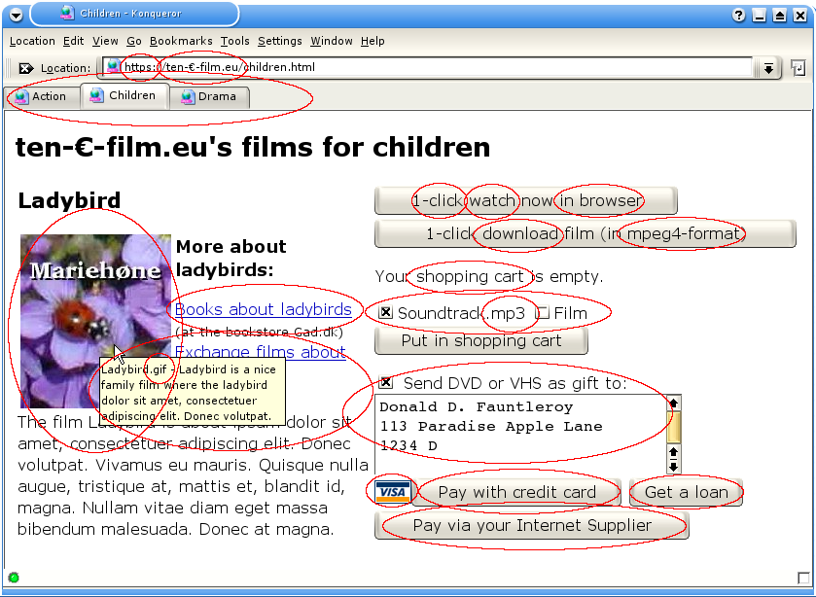
- 10€-video.eu - international characters in domain names: EP1159820
- [Action] [Children] [Drama] - Tabs: EP689133
- Ladybird is a nice ... - Pop up window: EP0537100
- Watch - Video streaming: EP0933892
- Download film - Video download (same as previous): EP0933892
- mpeg4 format - Widespread video format for download of video: More than 40 patents (including DK638218)
- Shopping cart - Electronic shopping cart: EP0784279
- Soundtrack.mp3 and Film - E-commerce with services: DK/EP738446
- Soundtrack.mp3 - MP3 is a widespread sound format: DK287578
- Pay with credit card - Credit card payment via the internet: EP820620
- Send as gift - Calculating correct address from incomplete information: EP927945
- Get a loan - Automatic loan: EP715740
- VISA - Digital signature in graphic file for checking the shop is authorized to accept VISA cards: EP0798657
- Pay via your Internet supplier - Payment via a telecommunication network: EP084836
- 1-click - Buy with one click: US5960411 (European application: EP0902381)
- https:// - SSL connections use encrypted sockets: US5657390
- in browser - Embedding a window in a browser: US5838906
- Books about ladybirds - Link to affiliate: US6029141
- Ladybird.gif - GIF files use LZW compression: EP129439
- https:// - SSL connections use RSA encryption: US4405829

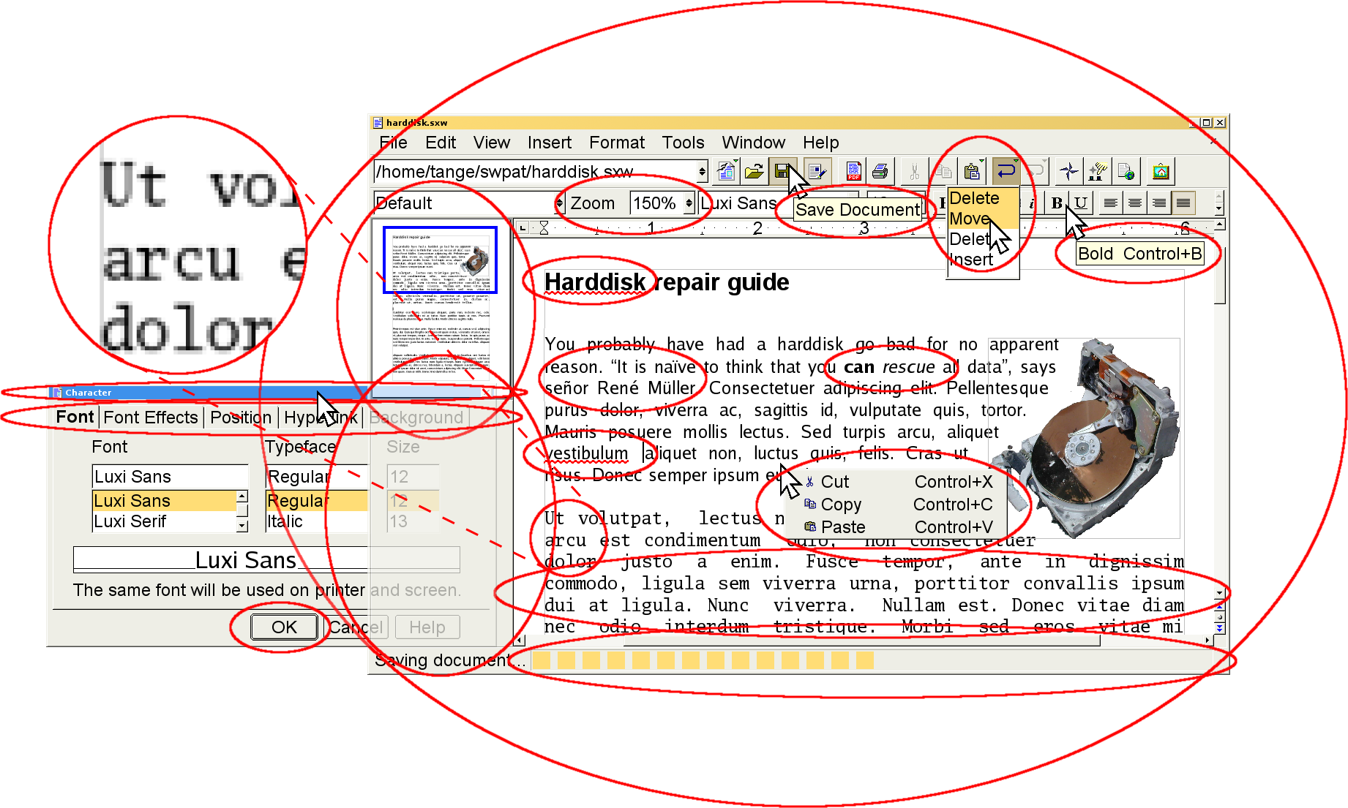
1
9
8
7
6
5
4
3
2
18
17
16
15
14
13
12
11
10

- EP281742: Spell check combined word
- EP214547 & EP772144 & EP693740:Anti-aliasing, stemming and hinting
- EP665489: Default activate "the right" field in a new window
- EP767419&EP349459 Bring to front & redraw hidden part
- EP689133: Tabs
- EP349459: Activate a window with mouse click
- EP348031: Miniature navigator
- EP743605: Enlargement of text
- EP537100: Tool tips
- EP621528: Multi level undo
- EP249293: Pop-up menu
- EP449322: Formatting text using input character
- EP573262: Formatting text with control code in document
- EP240909: Word processor with dead keys (e.g. accents and umlaut)
- EP394160: Progress bar
- EP205082: Justified text using spaces
- EP262804: Spell check after each word entered
- EP660248: Word Processor

