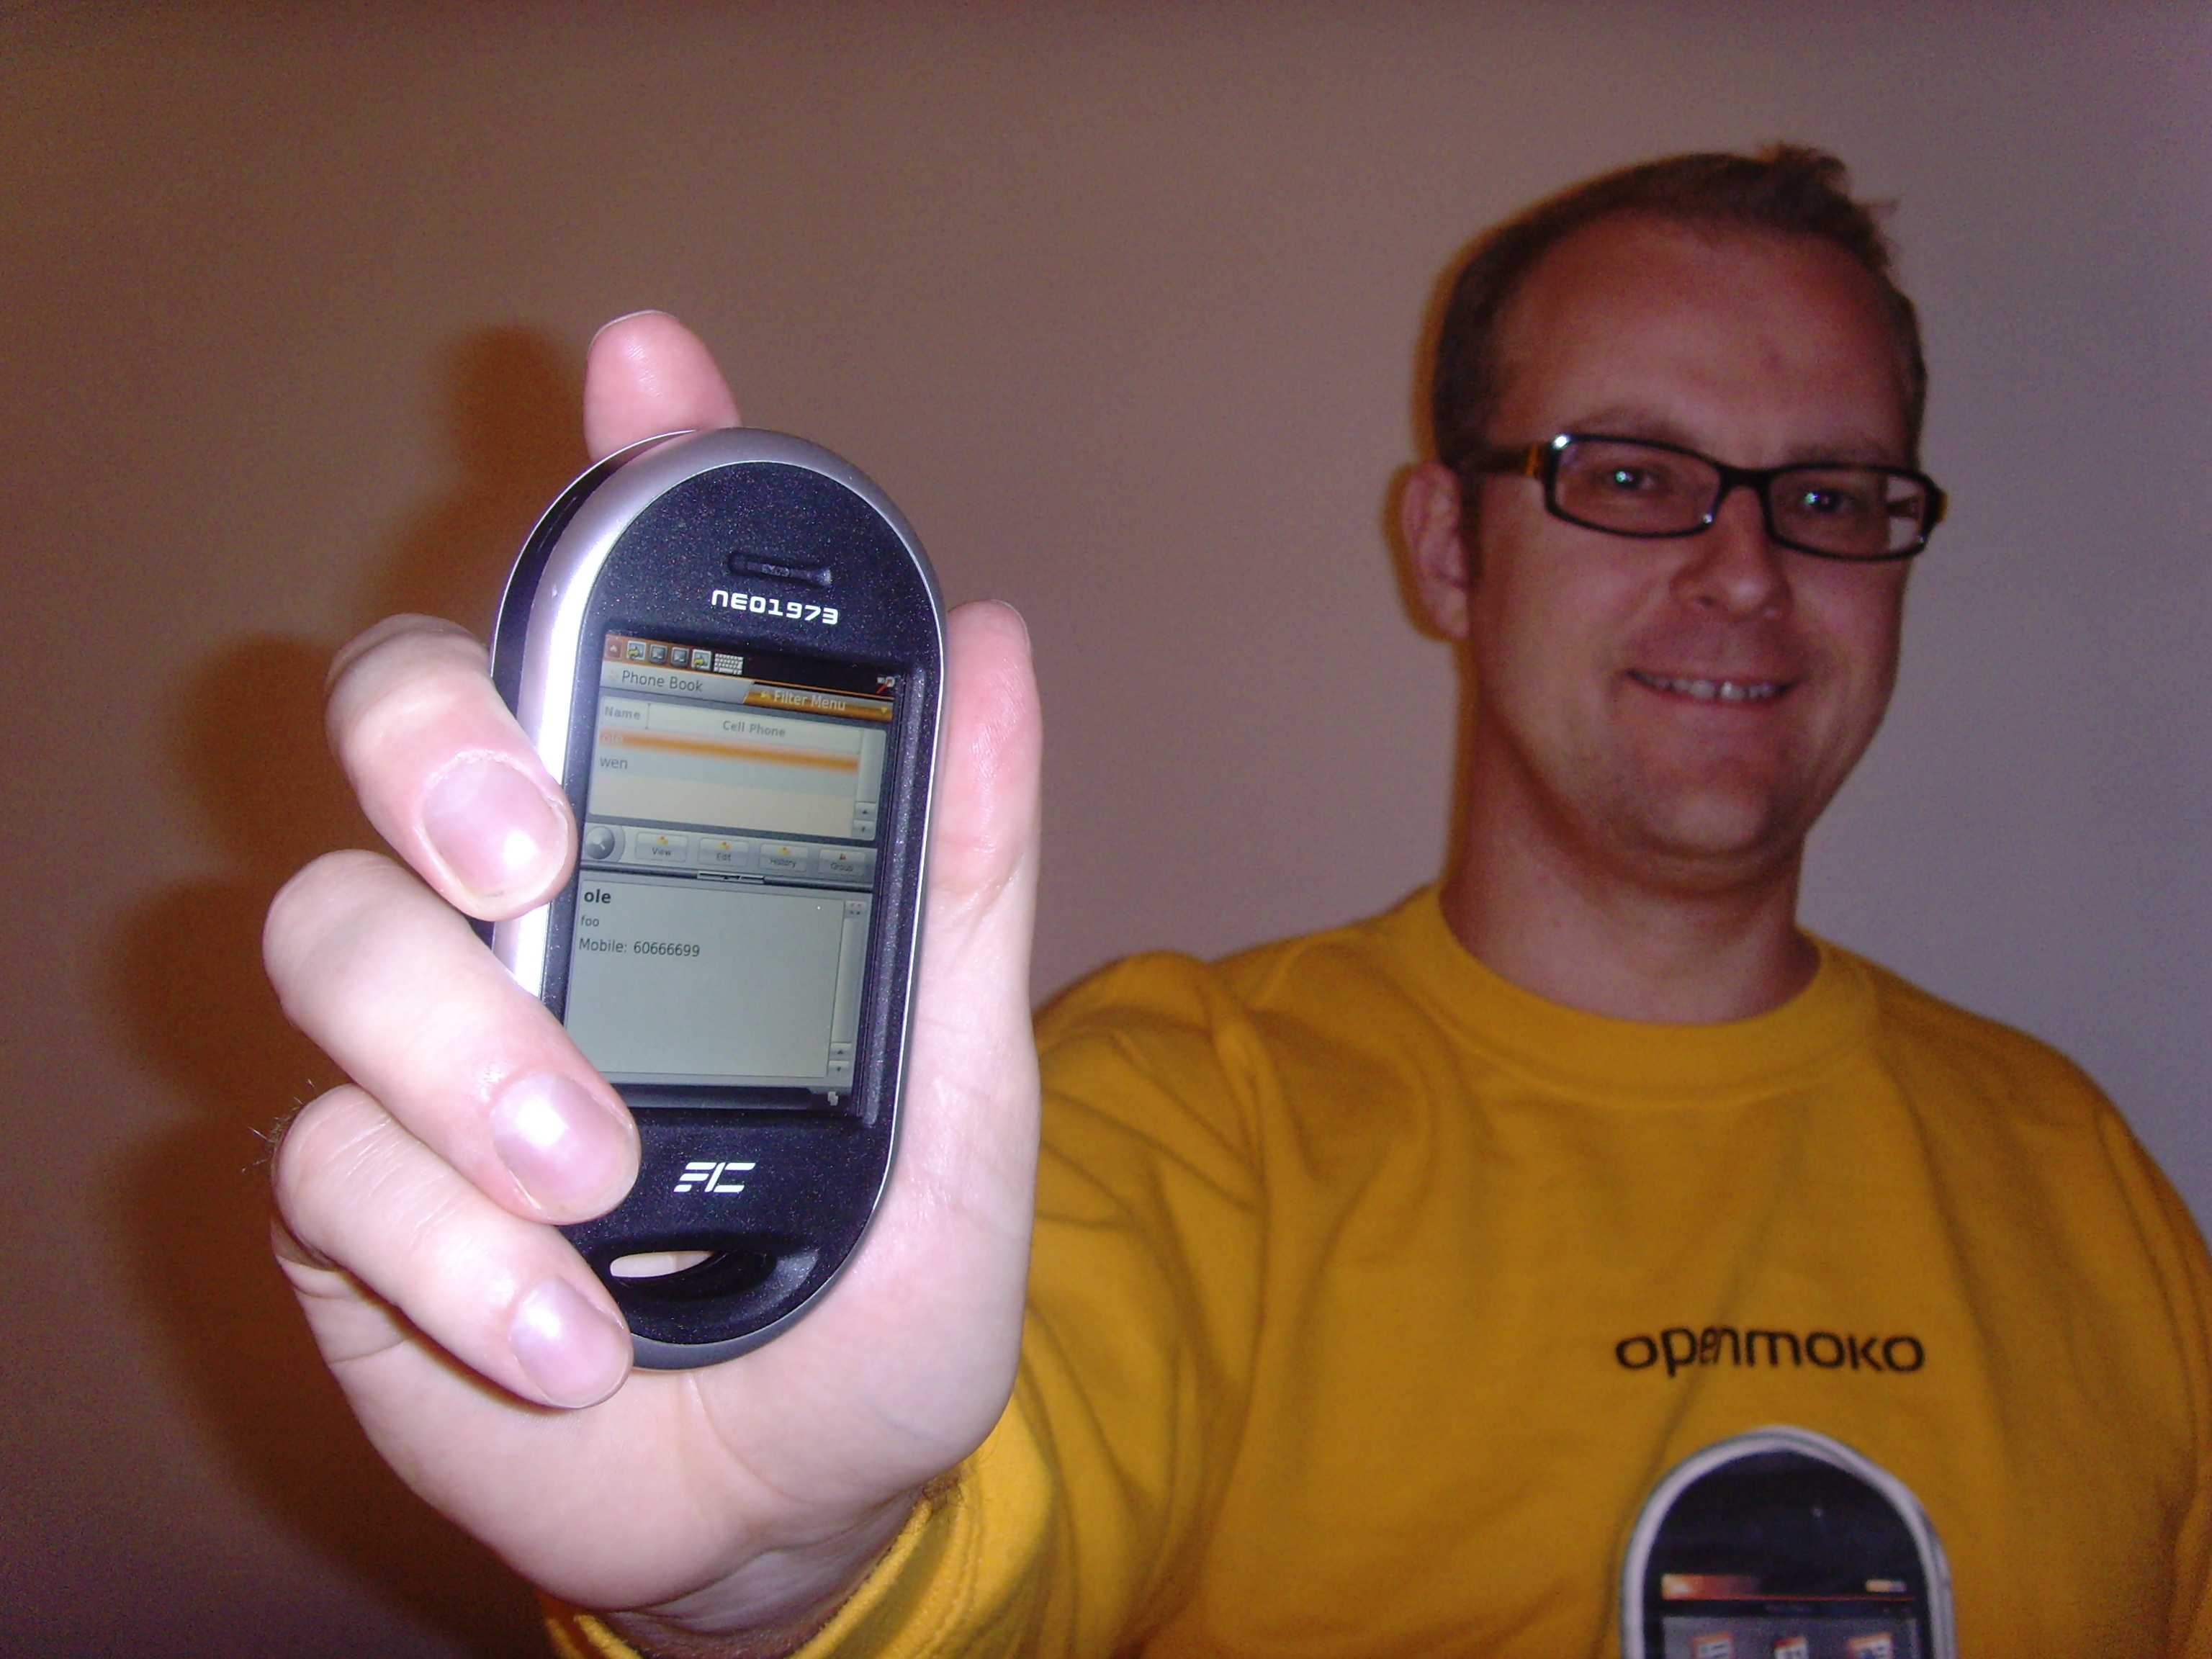
GNU/Linux on the mobile phone
- OpenMoko
See OpenMoko Friday October 10th at 7:30pm
Ground Floor, Dataran Kewangan Darul Takaful,
No 4, Jalan Sultan Sulaiman, 50000
Kuala Lumpur

OpenMoko is the GNU/Linux operating system running on the first free mobile phone, Neo Freerunner. Hear about OpenMoko and the thoughts behind it. It will also be possible to see a Neo Freerunner live.

Ole Tange has been involved in the OpenMoko project since November 2006. He sees a phone running only Free Software as the most disrupting thing that has happened since the introduction of GNU/Linux. He will present the possibilities a free phone gives.
Free your phone!

